Code :-

Updatedata:

import java.sql.Connection;
import java.sql.DriverManager;
import java.sql.ResultSet;
import java.sql.PreparedStatement;
import java.util.Scanner;
public class updateData {
public static void main(String[] args) throws Exception {
Class.forName("com.mysql.cj.jdbc.Driver");
String url = "jdbc:mysql://localhost:3306/studentdb";
Connection con = DriverManager.getConnection(url, "root", "");
Scanner sc = new Scanner(System.in);
System.out.println("Enter first name of user whose email ID need to be updated");
String fname = sc.nextLine();
System.out.println("Enter new emain ID");
String updated_email = sc.nextLine();
String Query = "update student set email=? where firstname=?";
PreparedStatement ps = con.prepareStatement(Query);
ps.setString(1, updated_email);
ps.setString(2, fname);
int i = ps.executeUpdate();
if (i > 0)
System.out.println("Your email ID updated");
else
System.out.println("Your record doesn't exist in database");
// -------- Display After Update --------
String Query1 = "select * from student";
PreparedStatement ps1 = con.prepareStatement(Query1);
ResultSet rs = ps1.executeQuery();
System.out.println("\n---- Records After Update ----");
while (rs.next()) {
String email = rs.getString(1);
String firstName = rs.getString(2);
System.out.println("Updated Email: " + email);
System.out.println("User Name: " + firstName);
System.out.println("-------------------------");
}
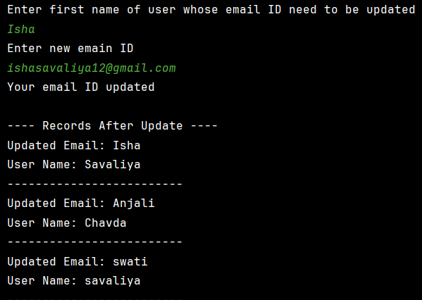

// write a JDBC program, which delete user from database, after record delete display record on screen
System.out.println("\nEnter first name of user to delete:");
String deleteName = sc.nextLine();
String deleteQuery = "DELETE FROM student WHERE firstname=?";
PreparedStatement ps2 = con.prepareStatement(deleteQuery);
ps2.setString(1, deleteName);
int j = ps2.executeUpdate();
if (j > 0)
System.out.println("Record deleted successfully.");
else
System.out.println("Record not found.");
System.out.println("\n---- Records After Delete ----");
String Query3 = "select * from student";
PreparedStatement ps3 = con.prepareStatement(Query3);
ResultSet rs1 = ps3.executeQuery();
while (rs1.next()) {
String email = rs1.getString(1);
String firstName = rs1.getString(2);
System.out.println("Updated Email: " + email);
System.out.println("User Name: " + firstName);
System.out.println("-------------------------");
}
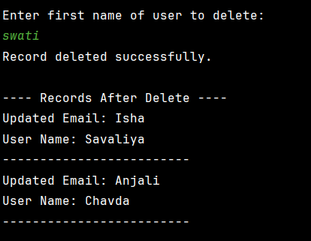

//write a JDBC program,which retrieve record of the user whose name start with 'a'
System.out.println("\n---- Records Whose Name Starts With 'a' ----");
String Query4 = "select * from student where firstname like 'a%'";
PreparedStatement ps4 = con.prepareStatement(Query4);
ResultSet rs2 = ps4.executeQuery();
while (rs2.next()) {
String email = rs2.getString(1);
String firstName = rs2.getString(2);
System.out.println("Email: " + email);
System.out.println("User Name: " + firstName);
System.out.println("-------------------------");
}
rs2.close();
ps4.close();
rs.close();
rs1.close();
ps.close();
ps1.close();
ps2.close();
ps3.close();
con.close();
sc.close();
}
}

